Print Name: ______________________________

Phone Number: ___________________________

School: _________________________________

Drawing will be held April 6, 2018.

Donation: $1.00
Proceeds will benefit
Illinois FBLA Foundation.

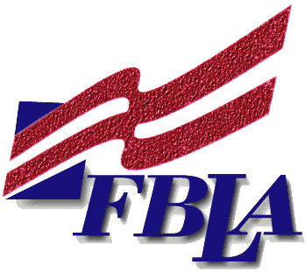
Prizes:
FBLA Prize
Raffle
- Hotel Package—Decatur Holiday Inn
- $100 Savings Bond
- Gift Basket

Prizes:
- Two $50 Amazon Gift Cards
- $50 Visa Gift Card; $50 Best Buy Gift Card
- $50 Wal-Mart Gift Card; $50 Macy’s Gift Card
- $50 Olive Garden Gift Card
- Amazon Echo Dot
- Starbucks Gift Basket; Netflix Basket
- Movie Gift Basket; Maryland Gift Basket
- Free Summer Leadership Workshop Registration
- And More!!!

- $50 Gift Card
- Flash Drive
- Free Summer Leadership Registrati
- And more…………

Print Name: ______________________________

Phone Number: ___________________________

School: _________________________________

Drawing will be held April 6, 2018.

Donation: $1.00
Proceeds will benefit
Illinois FBLA Foundation.

Prizes:
FBLA Prize
Raffle
- Hotel Package—Decatur Holiday Inn
- $100 Savings Bond
- Gift Basket

Prizes:
- Two $50 Amazon Gift Cards
- $50 Visa Gift Card; $50 Best Buy Gift Card
- $50 Wal-Mart Gift Card; $50 Macy’s Gift Card
- $50 Olive Garden Gift Card
- Amazon Echo Dot
- Starbucks Gift Basket; Netflix Basket
- Movie Gift Basket; Maryland Gift Basket
- Free Summer Leadership Workshop Registration
- And More!!!

- $50 Gift Card
- Flash Drive
- Free Summer Leadership Registrati
- And more…………

Print Name: _____________________________

Phone Number: __________________________

School: ________________________________

Drawing will be held April 6, 2018.
.

Donation: $1.00
Proceeds will benefit
Illinois FBLA Foundation.

Prizes:
FBLA Prize
Raffle
- Hotel Package—Decatur Holiday Inn
- $100 Savings Bond

Prizes:
- Two $50 Amazon Gift Cards
- $50 Visa Gift Card; $50 Best Buy Gift Card
- $50 Wal-Mart Gift Card; $50 Macy’s Gift Card
- $50 Olive Garden Gift Card
- Amazon Echo Dot
- Starbucks Gift Basket; Netflix Basket
- Movie Gift Basket; Maryland Gift Basket
- Free Summer Leadership Workshop Registration
- And More!!!

- Gift Basket
- $50 Gift Card
- Flash Drive
- Free Summer Leadership Registrati
- And more…………

